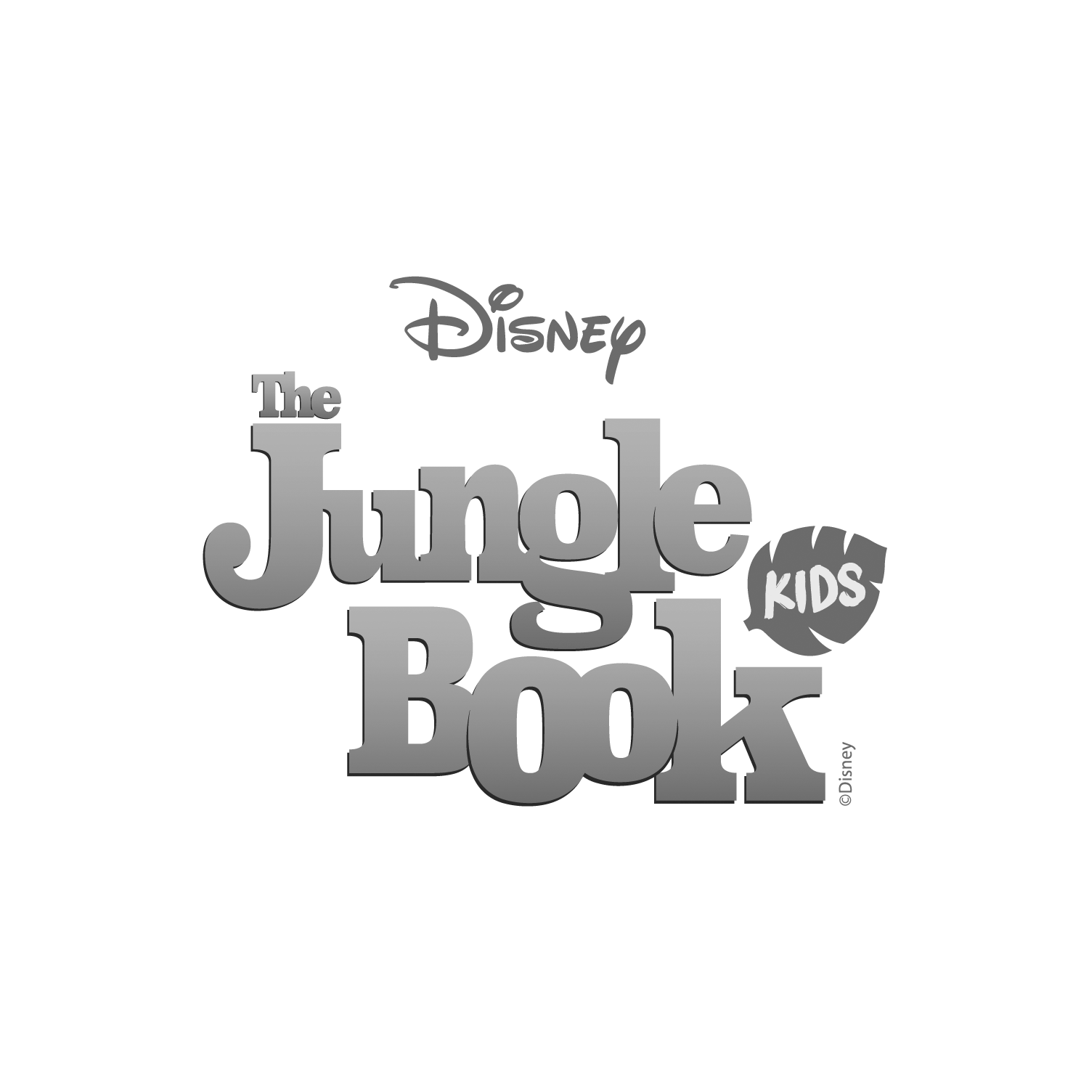

**ACS EGHAM INTERNATIONAL SCHOOL LS**

**Presents**

Music & Lyrics by

**Richard M. Sherman, Robert B. Sherman**

**& Terry Gilkyson**

Book Adapted & Additional Lyrics by

**Marcy Heisler**

Music Adapted & Arranged by

**Bryan Louiselle**

Based on the novel by Rudyard Kipling  
& the Disney film

Director

**Mags Grace, Jessica Page and Jude Vaughan**

Choreographer

**Jessica Page**

Music Director

**Mags Grace**

Stage Manager

**Sinead Dunphy**

Disney’s *The Jungle Book KIDS* is presented through special arrangement with

and all authorized materials are supplied by

Music Theatre International.

421 West 54th Street, New York, NY 10019

Script, music, and all other material © 2016 Disney Broadway Junior and MTI’s Broadway Junior Collection are trademarks

of Music Theatre International. All rights reserved.

Wednesday 30 March 09:00-10:15

Wednesday 30 March 13:00-14:15