

Presents
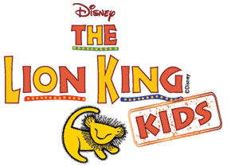

Music & Lyrics by
Elton John & Tim Rice

Additional Music & Lyrics by
Lebo M, Mark Mancina, Jay Rifkin, and Hans Zimmer

Book by
Roger Allers & Irene Mecchi

Based on the Broadway production directed by
Julie Taymor

Directors
Mags Grace and Jude Vaughan

Music and Choreography
Mags Grace and Jessica Page
Drama Director
Jude Vaughn

Stage Manager and Assistant Director
Sarah Garlick and Allan Bruce

Music Adapted & Arranged and
“Luau Hawaiian Treat” written by Will Van Dyke

Disney’s The Lion King KIDS is presented through special arrangement with
and all authorized materials are supplied by
Music Theatre International.
421 West 54th Street, New York, NY 10019
Script, music, and all other material © 2015 Disney
Broadway Junior and MTI’s Broadway Junior Collection are trademarks
of Music Theatre International. All rights reserved.

